|  |
| --- |
|  |
| QC Audit Tool - Functional Specification |
|  |
|  |
| **Document Revision History**   |  |  |  |  |  | | --- | --- | --- | --- | --- | | Ver# | Date | Author | Reviewer | Comments | | 1.0 | 04/26/2014 | Amy, Birney, Cindy | Cary Yu, Mandy Li | Initial Creation | | 1.1 | 07/16/2014 | Jimmy Qian | Cary Yu, Mandy Li | Added 4.6.4 Reassign for #61401 | | 1.2 | 07/21/2014 | Amy Luo | Cary Yu, Mandy Li | 1.Added 4.5 Audit Population for #62316  2.Updated 4.4 Audit Status for #63392  3.Updated section 4.6.7 for #61272 | | 1.3 | 11/11/2014 | Jimmy Qian | Cary Yu | Update section 5 for #72335 | | 1.4 | 12/24/2014 | Sally Ju | Fan Yu | 1.Updated 4.5 Audit Population for #77086, #83252  2.Updated 4.6.2 Workout Detail(get next workout) for #77079 | | 1.5 | 04/20/2015 | Wenqiao Jiang | Jimmy Qian,Venu | 1. Updated the changes made as part of QC Audit tool Enhancement Project SOW 71 , Update HAMP Denials ,HAMP Completed ,HAFA Denials, HAFA Completed from old tool to new tool for #80393  2.Update HAMP Closed to HAMP Negative NPV for #83252  3. Optimize data population logic for #99512 | | 1.6 | 01/29/2016 | Bing Zhu |  | Add Assumption Positive/Negative/Denial audit type | | 1.7 | 05/09/2016 | Alice Liu |  | Update 4.5 Audit Population for #135296 | | 1.8 | 07/18/2016 | Jacky Xu | Edwin Guru Singh | Added 4.6.9 : Added two new rows under Financial Test Section for #149332 | | 1.9 | 08/19/2016 | Edwin Guru Singh |  | Added Section 4.6.10 for #140407,#161627,#164266,#165710,#166612 | | 1.10 | 09/23/2016 | Edwin Guru Singh |  | Added Section 4.6.11 for #170351 : Facially Rewrite Project | | 1.11 | 11/08/2016 | Faiz Khan | Edwin Guru Singh | Added Section 4.6.12 for #147260 & #183242 | | 1.12 | 11/24/2016 | Edwin Guru Singh |  | Added Section 4.6.13 for #181075 | | 1.13 | 01/10/2017 | Edwin Guru Singh |  | Added Section 4.6.14/15/16 for #196812,#197348 & #199481 | | 1.14 | 01/23/2017 | Yang Mao | Edwin Guru Singh | Added Section 4.6.17 for #203579 | | 1.15 | 02/04/2017 | Yang Mao | Edwin Guru Singh | Added Section 4.6.18/19/20 for #130541,#182061,#183244 | | 1.16 | 03/27/2017 | Edwin Guru Singh |  | Modified Section 4.6.16 for #200257 Added Section 4.6.21/22 for #192609 Added Section 4.6.23 for #215450 | | 1.17 | 04/14/2017 | Faiz Khan |  | Modified Section 4.9.3 for #210748 | | 1.18 | 05/12/2017 | Edwin Guru Singh |  | Added Section 4.6.24 for #208938 | | 1.19 | 06/21/2017 | Edwin Guru Singh |  | Modified Section 4.6.2 & 4.6.3 for #225363 Modified Section 4.6.18 for #192606 & #192607 | | 1.20 | 07/25/2017 | Faiz Khan |  | Modified Section 4.6.18 for #235346 | | 1.21 | 09/15/2017 | Edwin Guru Singh |  | Added Section 4.6.25 for #217528 Added Section 4.6.26 for #189593 | | 1.22 | 10/13/2017 | Edwin Guru Singh |  | Modified Section 4.5 for #240111 | | 1.23 | 11/24/2017 | Edwin Guru Singh |  | Modified Section 4.6.16 for #248979 Added Section 4.6.27 for #232849 Added Section 4.6.28 for #235687 & #246162 Added Section 4.6.29 for #247250 | |
|  |

|  |
| --- |
|  |

Table of Contents

1 System Overview 5

2 Logging 6

3 Import Audits 7

3.1 Overview 7

3.2 Daily Process 7

4 Web Application 8

4.1 Security 8

4.2 Profiles and Permissions 8

4.3 Audit Type 8

4.4 Audit Status 9

4.5 Audit Population 9

4.6 Audit Page Functionality 11

4.6.1 Summary Tab 11

4.6.2 Workout Detail Tab 11

4.6.3 Search Tab 13

4.6.4 Audit screen 14

4.6.5 Audit Table Header Style 15

4.6.6 Audit Section 16

4.6.7 Audit “Submit” Functionality 17

4.6.8 Management Review 17

4.6.9 Financial Test Section 17

Added two new rows under the Financial Test Section 17

Those added two new rows which are applicable for the following Audit Types: 18

4.6.10 New Close/Denial reason added 19

4.6.11 Facially Rewrite 20

4.6.12 Short Sale Review & Short Sale Offer 20

4.6.13 Add New close reason as ‘PSA Restrictions’ to the “Assumption Denials” 21

4.6.14 Added New close reason as ‘Program Expired’ to the “HAMP/HAUP Denials” 21

4.6.15 Added New Product Audit Queue as “Deferral Denials/Approvals” 21

4.6.16 Added new table as “StatusReason” to display the Manual form/existing form for Non-Denial Products 22

4.6.17 Added New close reason as ‘Property Not Primary Residence’ to the “Assumption Denials” 26

4.6.18 Financial Test Section changes –Need to display some fields for Admin/Read-only Users 27

4.6.19 Added New Denial Reason as ‘HAMP-Not a Natural Person’ to the “HAMP Denials” 31

4.6.20 The denial reason of “Excessive Forbearance” needs to go to Assumption Negative NPV Queue. 32

4.6.21 Calculation logic updated for all NPV products 32

4.6.22 Admin users can able to edit the NPV values for HAMP Positive/Negative NPV 33

4.6.23 Added New Close Reason as ‘Investor Denied’ to the “Deferral Denials” 35

4.6.24 User can enter comments/notes as “&#” along with numerals in any textboxes 35

4.6.25 Added New Denial Reason as ‘Land Only’ to Denial products 36

4.6.26 Collateral Audits Request 37

4.6.27 Short Sale Review workout needs to populate into GSE Denials/Approvals Queue 37

4.6.28 Added New Product Audit Queue as “GSE Assumption Denials/Approvals” 38

4.6.29 Included the QC approved/denied workitem for all CFPB AuditTypes 39

4.7 Admin Tab Functionality 41

4.7.1 Cancel Workout 41

4.7.2 Unlock Workout 41

4.7.3 Populate Data 42

4.7.4 Reassign 42

4.8 HAMP/HAFA/HAUP Tab Functionality 42

4.8.1 Search 43

4.8.2 Events table 44

4.8.3 Audit screen 44

4.9 Functions 47

4.9.1 PDF File Generation 47

4.9.2 Common Data Copy 47

4.9.3 Actual/Alternate Option Form 47

4.9.4 POI Calculation 49

# System Overview

* Several stored procedures are used to load loans to audit tool.
  + Connect to Server SLLTS.
  + Get proper loans from FBRSQL database.
  + Insert the Loan summary information to DefaultAdministration.QC.Audit.
  + Insert the Loan detailed information to DefaultAdministration.QC.FieldValue for each field.
  + Insert work detail information to DefaultAdministration.QC.AuditWorkout.
* Auditor can start to audit by clicking “Get Next Workout”, or input a loan number in Workout Detail tab, or select one audit in Search tab.
* Auditor fills in the audit fields, completes the audit.

# Logging

User should register to login to this application. If the user doesn’t have access then the below screen will pop.

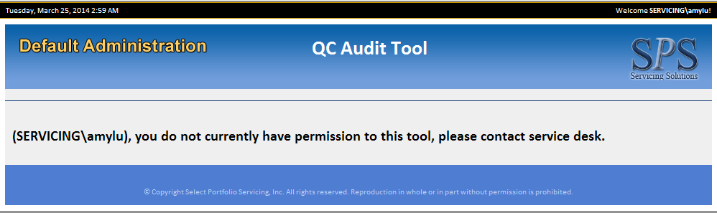

# Import Audits

## Overview

The stored procedures used to import audits are called daily in the job/SSIS Package.

The stored procedures are used to select loans from FBRSQL tables based on certain criteria for different types of loans and insert them into Default Administration database tables. CFPB population SSIS Package will be auto executed every half an hour. NonCFPB population SSIS Package will be auto executed every day at 5:30AM

## Daily Process

Each audit type has its own stored procedure. The process for each audit type is similar like below:

* Create temporary table in memory.
* Get proper records from FBRSQL and insert them into the temporary table.
* Insert the Loan summary information from temporary table to the DefaultAdministration.QC.Audit.
* Insert the Loan detailed information from temporary table to the DefaultAdministration.QC.FieldValue for each field.
* Insert the workout level information into DefaultAdministration.QC.AuditWorkout after all products imported.

# Web Application

## Security

User can access this application only if they have access to the application.

The access is granted in Application Command Center.

## Profiles and Permissions

In the App Command Center, two profiles are used for this application:

* NormalUserQCAuditTool

Can access below tabs:

* + Home/Workout Detail
  + Home/Search
  + HAMP/HAFA/HAUP Forms
* AdminQCAuditTool

User with this profile can access all the tabs.

* + Home/Workout Detail
  + Home/Search
  + HAMP/HAFA/HAUP Forms
  + Home/Summary
  + Home/Admin

## Audit Type

Audit Type indicates different audit queues. We have below audit types in our tool:

* BAC Negative NPV
* BAC Positive NPV
* BAC Denials
* CHAMP Negative NPV
* CHAMP Positive NPV
* CHAMP Denials
* NMS Negative NPV
* NMS Positive NPV
* HAMP Positive NPV
* HAMP Negative NPV
* SPS Positive NPV
* SPS Denied
* SPS Negative NPV
* NMS Denials
* HAMP Closed
* HAMP Denials ( New Audit type , all the deals coming into HAMP closed will be queued to this type)
* HAMP Completed
* HAFA Denied
* HAFA Denials( New Audit type , all the deals coming into HAMP Denied will be queued to this type)
* HAFA Completed
* HAUP Completed
* HAUP Denied
* Assumption Positive NPV(All the Assumption workout with Positive NPV will be queued to this type)
* Assumption Negative NPV(All the Assumption workout with Negative NPV will be queued to this type)
* Assumption Denials(All the Denial Assumption workout will be queued to this type)

Basically, one audit type use one audit form, Different audit type use different audit form. But there are exceptions:

1. Actual/Alternate Option form (View Details)
2. Product “SPS Trial Mod” and “SPS ALT Trial Mod” share audit type “SPS Positive NPV”, “SPS Negative NPV”, “SPS Denied”, but the audit form for two products is different. Among them, the difference of “SPS Denied” for two products is minor, just about one field.

## Audit Status

The different audit statuses are as below and each audit must have any one of the statuses

* Queued – New Audit and imported by stored procedure
* Processing – When user clicks “select” in Workout Detail tab or select an audit in Search tab, all audits in “Review/Queued/Rework” status, will change to processing
* Complete –

For Non-CFPB data, status changes to Complete when the audit is submitted by the user.

For CFPB data, when the audit is submitted by the user and all audits in this workout passed audit.

* Review – Sent it to review for management purpose, when user clicks “Management Review” link.
* Resolution Pending – For CFPB data only, when the audit is submitted by the user and any product in this workout failed audit.
* Rework – We don’t populate this status at present.
* Cancelled – For CFPB data only, audits can be cancelled by a given workout ID under Home/Admin/Cancel Workout.

## Audit Population

**CFPB**

1. If the workout is closed by Customer Request, Access Issues for Property Valuation, Transfer of Ownership, populate audits to Closed/Denial queue.
2. If the product has denial reason, populate audits to Closed/Denial queue.
3. If the product doesn’t have denial reason, then based one NPV result, populate audits to Positive/Negative NPV queue.
4. If the workout  has 3 failed history, populate audits to manager review queue as the 4th.

Exceptions for the 2nd point:

If the denial reason is not valid, populate audits to Positive NPV queue directly.

If the denial reason is “Failed NPV”/” Modification not feasible”/” HAMP-Insufficient Payment Reduction”/” HAMP-Excessive Forbearance”/” HAMP-DTI Outside of Acceptable range”/” HAMP-DTI Less than 31%”/”HAMP-Insufficient Payment Reduction”/” HAMP-Excessive Forbearance”/” HAMP-DTI Outside of Acceptable range”/” HAMP-DTI Less than 31%”, populate audits to Negative NPV queue.

Fixed for Dirty records & to avoid any deadlock in the SSIS package by below approach.

* Implemented transactions at stored procedure level so that in case of any failure the changes done by the SP will be rolled back.
* Execute the SQL Task in SSIS package in sequential flow(blue) irrespective of the result of previous task. (as shown in below screen shots)
* For existing dirty data we have created one time script to clean it from AuditWorkout table.
* Note : The color of connection between the tasks(constraints) ‘Green for Success’, ‘Red for Failure’ and ‘Blue for Completion’.

PFB, SSIS looks like before fix :  
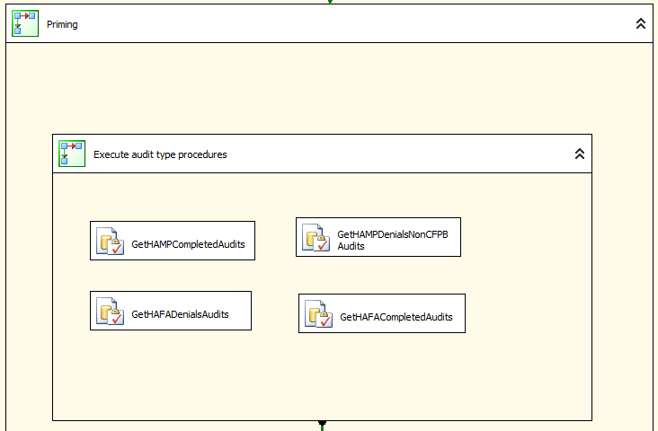

PFB, SSIS looks like after fix :  
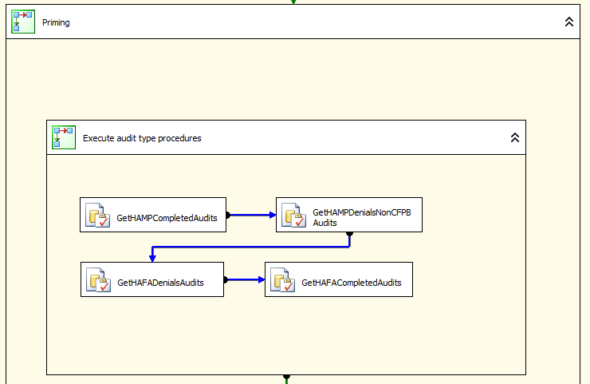

## Audit Page Functionality

* Every audit type has its own page/tab and it will display the audit loans for that audit type.
* These audits are loaded by stored procedure in to Default Administration Database.

### Summary Tab

Product section displays the count of each audit status for every audit type.

Workout section is the count for workout level.

### Workout Detail Tab

This tab contains 4 sections.

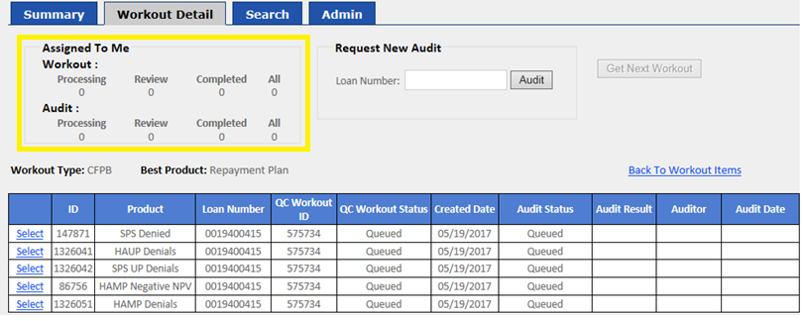

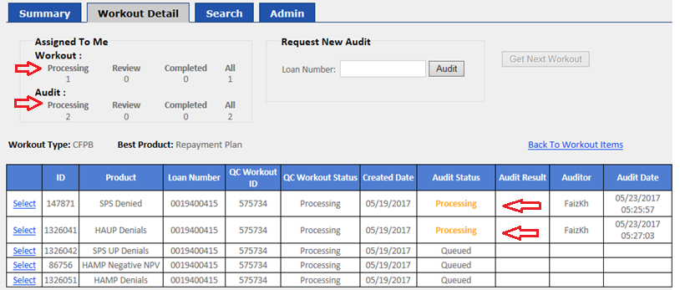

#### Assigned To Me

This section lists the number of audits in different status for current user by workout & Audit level.  
Note : One workout may have multiple Audits.

#### Request New Audit

User can get the top one Audit Workout record whose loan number is same as input loan number was ordered by AuditOrder and AuditOrderDate.

#### Get Next Workout

This will get next available workout for both CFPB and nonCFPB data.

The criteria as below:

1. Based on the timeline to assign loans to users; get the most urgent items to users; Admin users can set the timeline.
2. If there are more than one item which have same timeline, get one item ordered by AuditOrder.
3. If there are still more than one item after (1,2), get one item ordered by AuditOrderDate.
4. The “Get Next Workout” button will be disabled for the Auditor if there is any Workout in processing state assigned to auditor

The Logic in the code: System will order by timeline, AuditOrder and AuditOrderDate, try to get the top one Workout . Only Admin users can get “Review” items, and “Modified By” couldn’t be themselves. After retrieving the record, system will update this record and change its Auditor and ModifiedBy as current user.

AuditOrder: This is the audit order of workout status, defined in the QC.WorkoutStatus table.

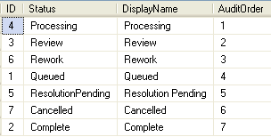

AuditOrderDate: This is audit level, the value is audit created date, or audit requested date.

#### Workout Detail

List all the records belongs to this workout.

By clicking the Select button, user is able to start to audit.

### Search Tab

* Initially when the page loads it displays all the audits with the below criteria
  + Audit status =’ Queued’
  + Start Date = ‘09/24/2013’
  + End Date = Current date
* **Search Criteria**:
* Loan Number
* QC Workout ID
* Start Date (refer to Audit imported date)
* End Date(refer to Audit imported date)
* Product(refer to audit type)
* Audit Status
* Auditor
* Source(CFPB/NonCFPB)
* Workout Status

By double clicking the row of search result, user is able to audit.

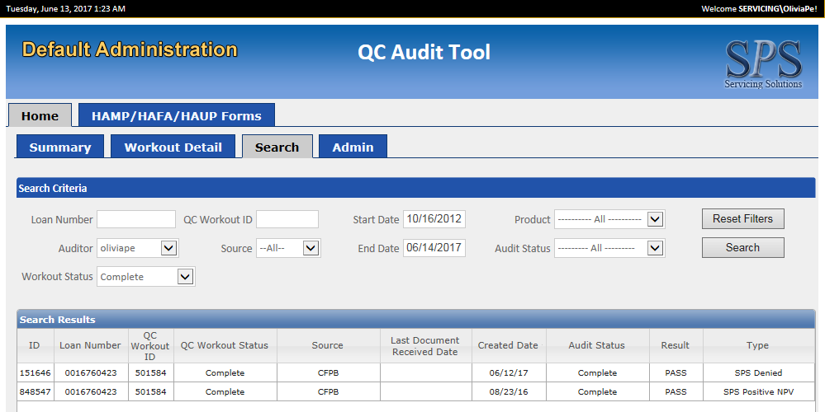

### Audit screen

Screen like below comes when the user audits a particular loan.

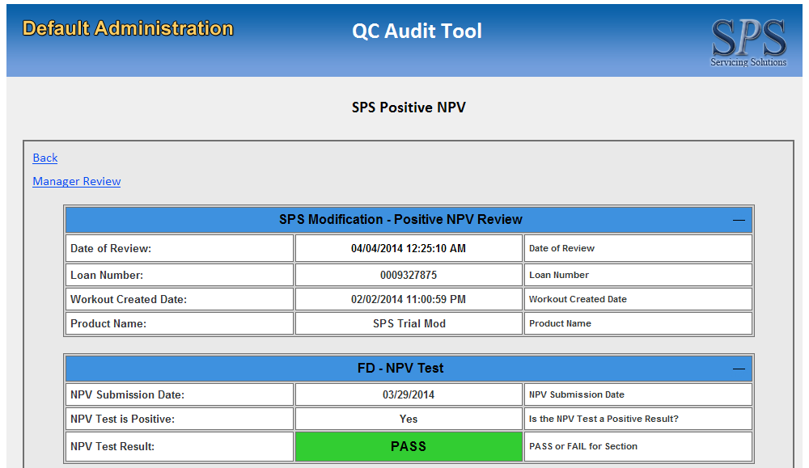

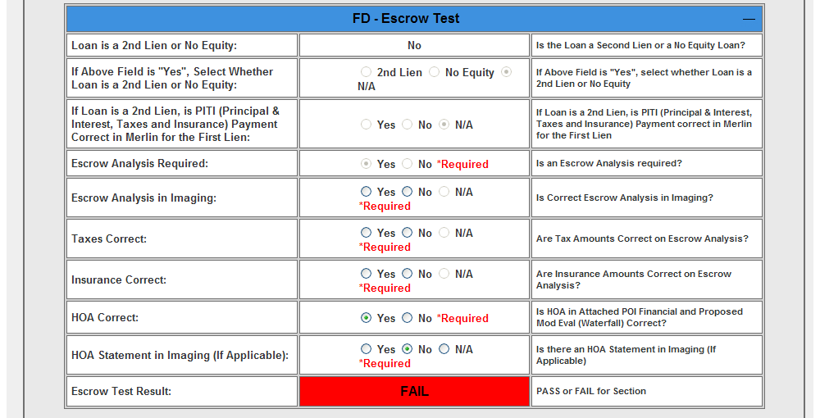

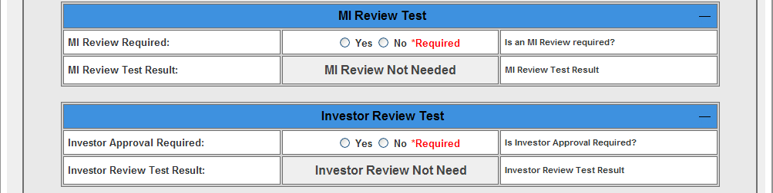

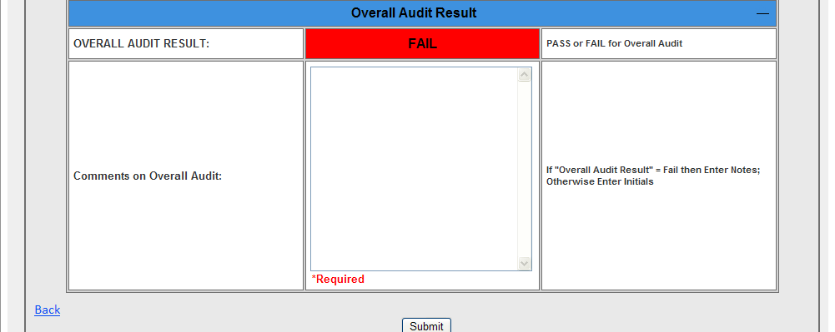

### Audit Table Header Style

Audit table Header color is different across different type of audits.

Header style for the audit types associated with keywords “Denials”/”Denied”/”Closed”/”Negative”

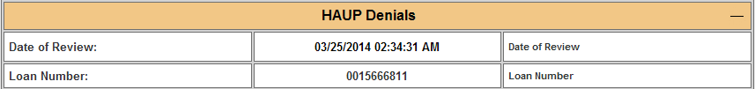

Header style for the audit types associated with keywords “Approvals”/”Positive”

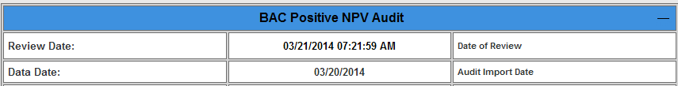

### Audit Section

The selected audit contains multiple sections

* **Audit Section:**

Different audit type has different sections; each section has their own test result.

* **Audit Field:**

There are different fields defined for each section.

User must enter all the required fields’ value in each audit section, then the test result (PASS/FAIL/REVIEW NEEDED) or any other derived column data will be calculated automatically based on the business logic after the field value has been changed.

Some Fields values are derived from the other fields’ data for ex: Based on the Date of CBR value Aging of CBR is calculated.

Some Fields values are changed from Mandatory to optional based on the other fields data. For Ex:

* If the CBR value is yes then Date of CBR,Name and SS# Correct, CBR Scores Entered Correctly are mandatory.
* If the CBR value is No then Date of CBR,Name and SS# Correct, CBR Scores Entered Correctly are not required.

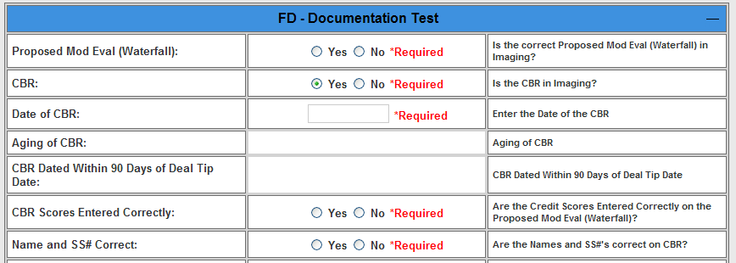

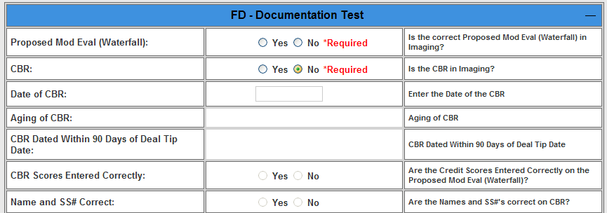

### Audit “Submit” Functionality

When user clicks the “Submit” button:

* Pop up a warning message if any required fields are blank, and highlight those fields.
* After validation successfully, a PDF file will be generated in configured path.
* Update common field data in table QC.SharableValue for **CFPB** data.
* Update field values in table QC.FieldValue.
* Audit status will be changed from **Processing** to **Complete**/**ResolutionPending**, based on **non-CFPB**/**CFPB** record.
* Update ContactHistory.
* Collects latest products audit information, and insert into system request pipeline for **CFPB** data.
* Alert message “Please also update checklist step for this loan.” for **non-CFPB** data.

### Management Review

By clicking “Manager Review” button, it will send an email to specific group (defined in table QC.ConfigInfo, ConfigKey: ReviewDistributionList), and this audit’s status will be changed from “**Processing”** to “**Review”**.

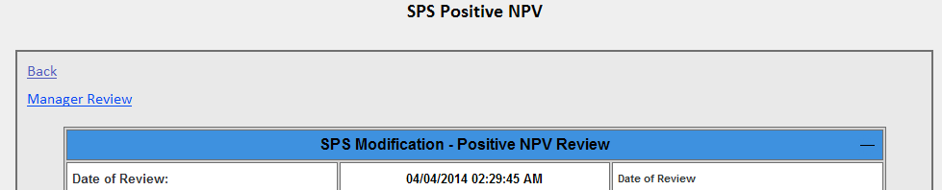

### Financial Test Section

### Added two new rows under the Financial Test Section

* UnEmployment Income Amount :
  + This value will be retrieved from SelectCE : ”Grossed Up Monthly“ under the tab “Financial Statement/Borrower information” based on respective product category.
* Income from Attached Financial(“POI”) excluding any unemployment Income :
  + The subtraction value between POI and Unemployment Income amount.

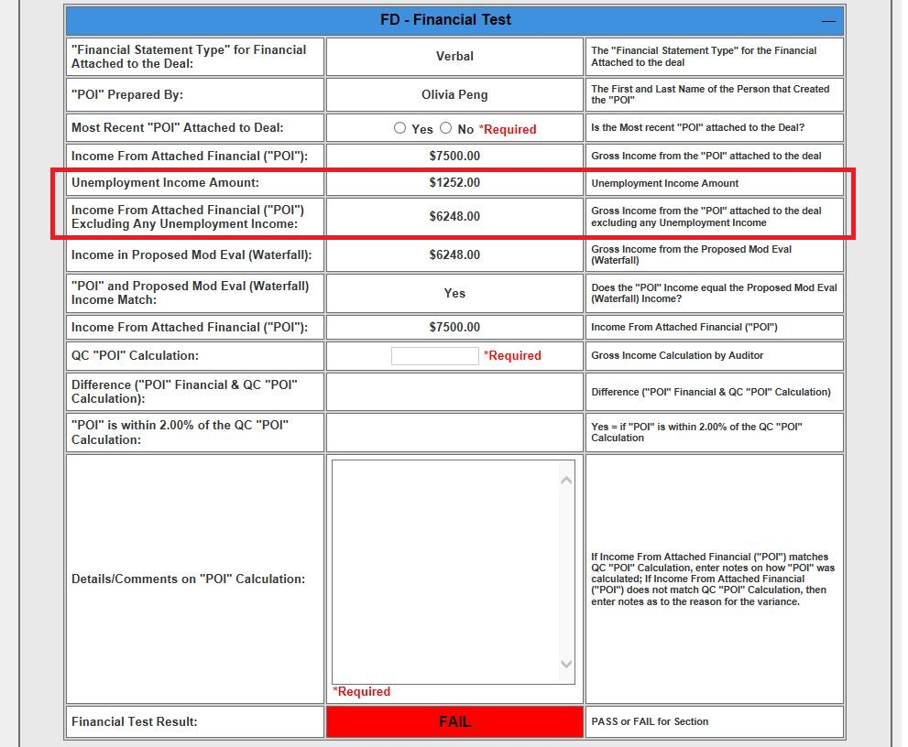

### Those added two new rows which are applicable for the following Audit Types:

|  |  |  |  |
| --- | --- | --- | --- |
| **SNo** | **Audit Type** | **Source** | |
| **CFPB** | **Non-CFPB** |
|  | BAC Negative/Positive NPV | Yes | Yes |
|  | Champ Negative/Positive NPV | Yes | Yes |
|  | NMS Negative/Positive NPV | Yes | Yes |
|  | NMS Denials | Yes | Yes |
|  | HAMP Negative/Positive NPV | Yes | Yes |
|  | HAMP Denials -Tier1 | Yes | Yes |
|  | SPS/SPS ALT Negative /Positive NPV | Yes | N/A |
|  | SPS/SPS ALT Denied | Yes | N/A |
|  | Assumption Negative/Positive NPV | Yes | N/A |

### New Close/Denial reason added

|  |  |  |
| --- | --- | --- |
| **SNo** | **Audit Type** | **Close/Denial Reason** |
|
|  | CHAMP Denials | Senior Lien in Default |
|  | CHAMP Negative NPV | PreMod DTI Less than Allowed |
|  | CHAMP Negative NPV | Excessive Forbearance |
|  | Assumption Denials | Bankruptcy Court Declined |
|  | Assumption Denials | Discharged BK not reaffirmed |
|  | Assumption Denials | Legal Documents specify another resolution |
|  | HAUP Denials | HAMP-DTI Outside of Acceptable range |
|  | Assumption/BAC/CHAMP/HAMP/HAUP/NMS/SPS UP Denials, SPS Denied | Application Inactivity |

#### CHAMP Negative NPV

Populate Chase Junior Liens with results of 'PreMod DTI Less than Allowed” and “Excessive Forbearance” for CHAMP Negative NPV.

* If loan is a 1st lien, populate the existing form.
* If loan is a 2nd Lien, populate the new audit page (Chase Negative NPV form – Jr. Lien Write-up).

#### CHAMP Positive NPV

Populate Chase Junior Liens with Positive NPV results for CHAMP Negative NPV.

* If loan is a 1st lien, populate the existing form.
* If loan is a 2nd Lien, populate the new audit page (Chase Positive NPV form – Jr. Lien Write-up).

#### CHAMP Denials

Populate all other Chase Junior Lien denials for CHAMP Denials.

* Add new audit page to CHAMP denials of “Senior Lien in Default” and show in drop down only when Lien Position is 2nd.
* Add new audit page to CHAMP denials of 'Manual Review' and display the denial reasons in the drop down if the loan is a 2nd lien.

### Facially Rewrite

|  |  |  |  |  |
| --- | --- | --- | --- | --- |
| SNo. | **Product Name** | **Source Type** | **New / Old Tool** | **Close Reason** |
|  | BAC Denials | CFPB | New | CFPB - Required Docs not Received - FC Sale Within 37 Days |
|  | CHAMP Denials -1st Lien | CFPB |
|  | CHAMP Denials -2nd Lien | CFPB |
|  | HAMP Denials - T1 | CFPB |
|  | HAMP Denials - T2 | CFPB |
|  | HAUP Denials | CFPB |
|  | SPS UP Denials | CFPB |
|  | SPS Denied | CFPB | Old | CFPB - Required Docs not Received - FC Sale Within 37 Days |
|  | SPS Alt Denied | CFPB |

#### Was at Least One Document Received From Borrower?

Was at Least One Document Received From Borrower? If yes then the sub section will display based on “Partial Doc” otherwise the sub section will display based on “No Doc”

* FC Sale Date
* Expiration Notices
* Borrower Documents

Overall Audit Result will be “Pass” when all of the above sections are passed.

### Short Sale Review & Short Sale Offer

|  |  |  |  |  |
| --- | --- | --- | --- | --- |
| SNo. | **Product Name** | **Source Type** | **New / Old Tool** | **Close Reason** |
| 1 | HAFA Denials | CFPB (HAFA Short Sale Review – Listing Period & HAFA Short Sale Review – No Listing Period) | New | Customer Request  Full Payoff Required  HAFA Ineligible  Investor Denied  Loan Paid in Full  Manual Review  Mortgage Insurer Denied  Negotiations with other liens unsuccessful  No Response from borrower  Open or Pending Insurance Claim  Required Documents not received  Scheduled FC Sale Date  Servicing Transfer  Unable to complete Interior Value  Unable to use Insurance Proceeds |

### Add New close reason as ‘PSA Restrictions’ to the “Assumption Denials”

Added new Denial/Close reason as “PSA Restrictions’ to the Product “Assumption Denials” only.  
The following fields are displaying under new Audit Form When choose the close reason as ‘PSA Restrictions’

* Underwriter Note in Contact History Requesting Denial for PSA Restrictions
* Date of Note
* Name of Person Entering Note
* Confirmed in Qualifications and/or the Agreement in SelectCE that an Assumption Modification is Not Allowed Due to a PSA Restriction.

### Added New close reason as ‘Program Expired’ to the “HAMP/HAUP Denials”

Added new Close reason as “Program Expired’ to the Product “HAMP/HAUP Denials” only.  
The existing Audit Form (Manual Review) will display to audit When choose the close reason as ‘Program Expired’

### Added New Product Audit Queue as “Deferral Denials/Approvals”

Added new Product Audit Queue as “Deferral Denials” and “Deferral Approvals”.  
The below table contains the Close reason with audit form details for the respective Product.

|  |  |  |
| --- | --- | --- |
| **Product Audit Queue** | **Close Reason** | **Audit Form** |
| SPS UP Denials (Existing) | FC Sale < 30 Days | Manual Review form |
| Deferral Denials (New) | FC Sale < 7 Days | Manual Review form |
| Required Documents not Received | Manual Review form |
| Insufficient Recent Payments | Manual Review form |
| PSA Restrictions | Manual Review form |
| MI Restrictions | Manual Review form |
| Customer Request | Existing Form |
| Access Issues for Property Valuation | Existing Form |
| Transfer of Ownership | Existing Form |
| Application Inactivity | Manual Review form |
| Manual Review | Manual Review form |
| Deferral Approvals (New) | NA | Manual Review form |

### Added new table as “StatusReason” to display the Manual form/existing form for Non-Denial Products

Table Name : **[DefaultAdministration].[QC].[StatusReason]**

|  |  |  |
| --- | --- | --- |
| **Column_Name** | **Type** | **Length** |
| StatusReasonId | int | 4 |
| Name | varchar | 100 |
| Description | varchar | 200 |
| AuditTypeID | int | 4 |
| CreatedBy | varchar | 100 |
| CreatedDate | datetime | 8 |
| ModifiedBy | varchar | 100 |
| ModifiedDate | datetime | 8 |
| ActiveFlag | bit | 1 |

Added new dropdownlist as “Approval/Review Reason” which are retrieving from StatusReason table for the following Products:

|  |  |  |  |
| --- | --- | --- | --- |
| **Audit Type** | **Product Name** | **Approval/Review Reason** | **Audit Form** |
| SPS Negative NPV | SPS Trial Mod | SPS Modification - Negative NPV Review | Existing form |
| SPS Trial Mod | Manual Review | Manual Review form |
| SPS Positive NPV | SPS Trial Mod | SPS Modification - Positive NPV Review | Existing form |
| SPS Trial Mod | Manual Review | Manual Review form |
| SPS UP Approvals | SPS UnEmployment | SPS UP - Approval Review | Existing form |
| SPS UnEmployment | Manual Review | Manual Review form |
| BAC Negative NPV | BAC Negative NPV | BAC Negative NPV Review | Existing form |
| BAC Negative NPV | Manual Review | Manual Review form |
| BAC Positive NPV | BAC Positive NPV | BAC Positive NPV Review | Existing form |
| BAC Positive NPV | Manual Review | Manual Review form |
| CHAMP Negative NPV | CHAMP Negative NPV | CHAMP Negative NPV Review | Existing form |
| CHAMP Negative NPV | Manual Review | Manual Review form |
| CHAMP Positive NPV | CHAMP Positive NPV | CHAMP Positive NPV Review | Existing form |
| CHAMP Positive NPV | Manual Review | Manual Review form |
| Assumptions Negative NPV | Assumptions Negative NPV | Assumptions Negative NPV Review | Existing form |
| Assumptions Negative NPV | Manual Review | Manual Review form |
| Assumptions Positive NPV | Assumptions Positive NPV | Assumptions Positive NPV Review | Existing form |
| Assumptions Positive NPV | Manual Review | Manual Review form |
| GSE Assumption Denials | GSE Assumptions Denials | GSE Assumptions Denials Review | Existing form |
| GSE Assumptions Denials | Manual Review | Manual Review form |
| GSE Assumption Approvals | GSE Assumption Approvals | GSE Assumption Approvals Review | Existing form |
| GSE Assumption Approvals | Manual Review | Manual Review form |

**ScreenShot :** Approval/Review Reason as “SPS Modication - Negative NPV Review”  
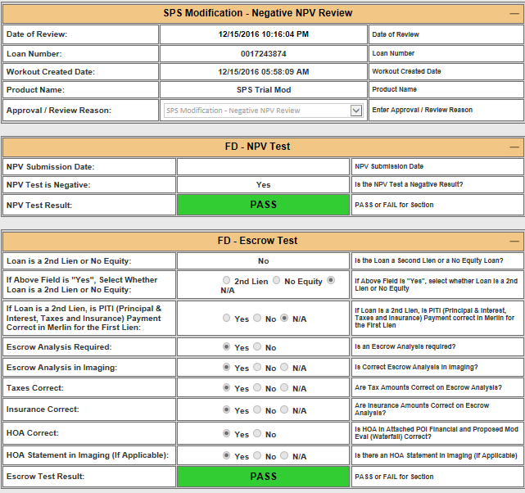

**ScreenShot :** Approval/Review Reason as “Manual Review”

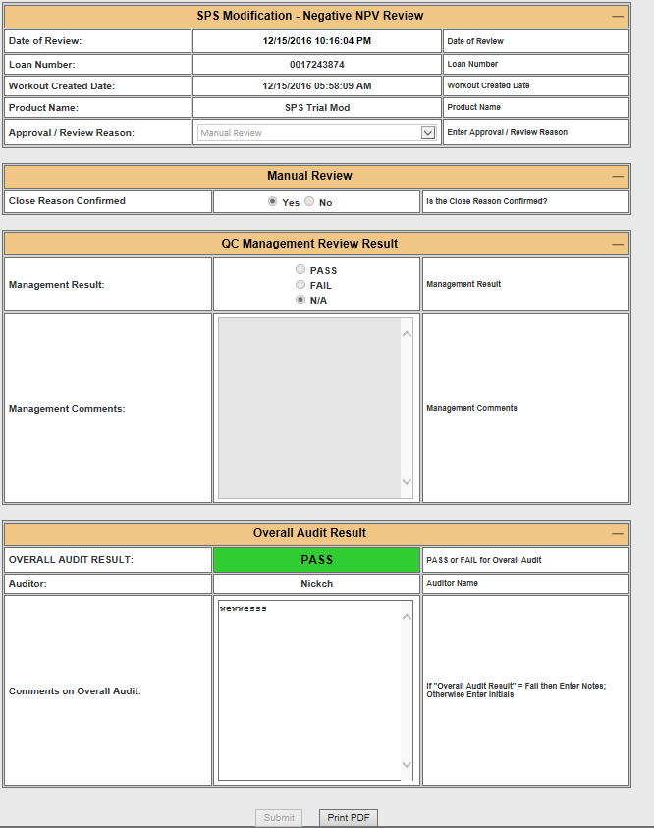

### Added New close reason as ‘Property Not Primary Residence’ to the “Assumption Denials”

Added new Close reason as ‘Property Not Primary Residence’ to the Product “Assumption Denials” only.  
The existing Audit Form (Manual Review) will display to audit When choose the close reason as ‘Property Not Primary Residence’.

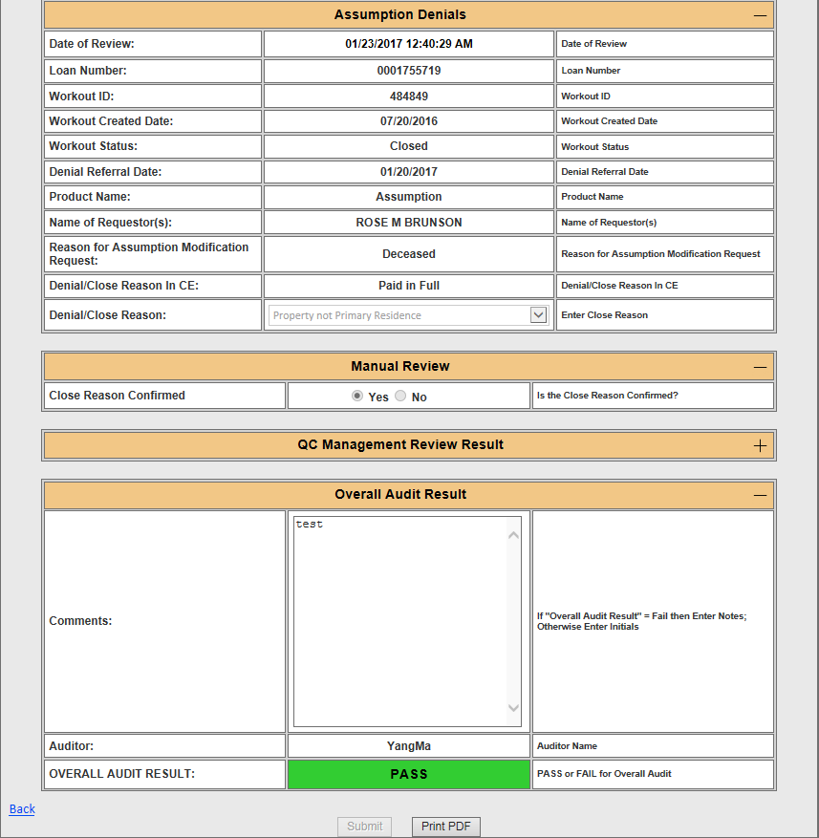

### Financial Test Section changes –Need to display some fields for Admin/Read-only Users

The following three fields(rows) has to displayed for Admin/Read-only users whereas doesn't has to be displayed for Normal user, Also those field’s backend calculations will not happen when normal user access this section.

* Gross Income from the POI Attached to the deal
* The Income entered into the waterfall
* Income from Attached financial

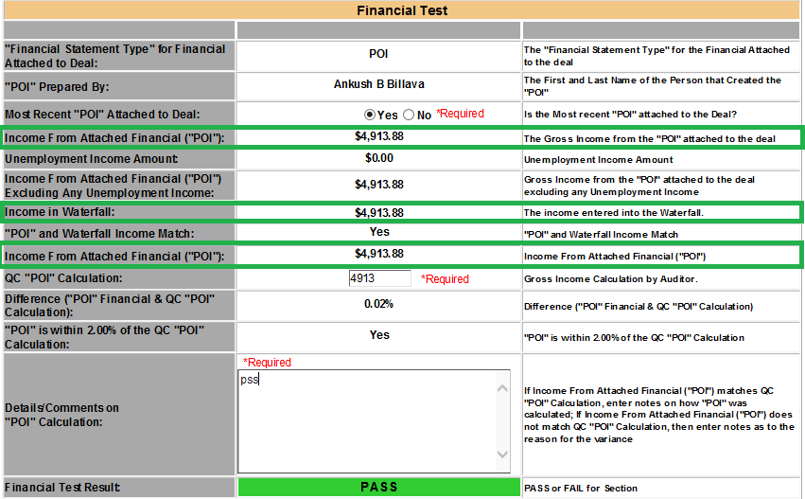

Updated the below logic for HOA:  
Updated the logic to retrieve the “SpreadMonthlyAmount” value based on “EscrowEvaluationId” instead of Loan_No. The applicable audits are Hamp Positive NPV & HAMP Negative NPV for both source(CFPB,Non-CFPB).

1. hmpModNPV.MonthlyAssociationDuesFees as 'HOAInWaterfall'
2. hmpModNPV.MonthlyAssociationDuesFees as 'HOAFromWaterfall'
3. CASE WHEN (hmpModNPV.MonthlyAssociationDuesFees = AttachedPOI.HOAFromFinancial) THEN 1 ELSE 0 END as 'HOAPassFail'
4. hmpEscrow.SpreadMonthlyAmount as 'ShortageFromWaterfall'
5. COALESCE(hmpModNPV.PrincipalandInterestPaymentAfterModification,0) + COALESCE(hmpModNPV.MonthlyRealEstateTaxes,0) + COALESCE(hmpModNPV.MonthlyHazardInsuranceAndFlood,0) + COALESCE(hmpEscrow.SpreadMonthlyAmount,0) as 'ModificationPayment'

Updated the below logic for Food Stamp Income :  
 Modified the logic in Financial Statement to retrieving the value of “Grossed up monthly” amount instead of “Gross Monthly pay” amount. PFB screenshot  
Applicable products :

* HAMP Positive/Negative NPV
* CHAMP Positive/Negative NPV
* BAC Positive/Negative NPV
* SPS Positive/Negative NPV
* Assumption Positive/Negative NPV

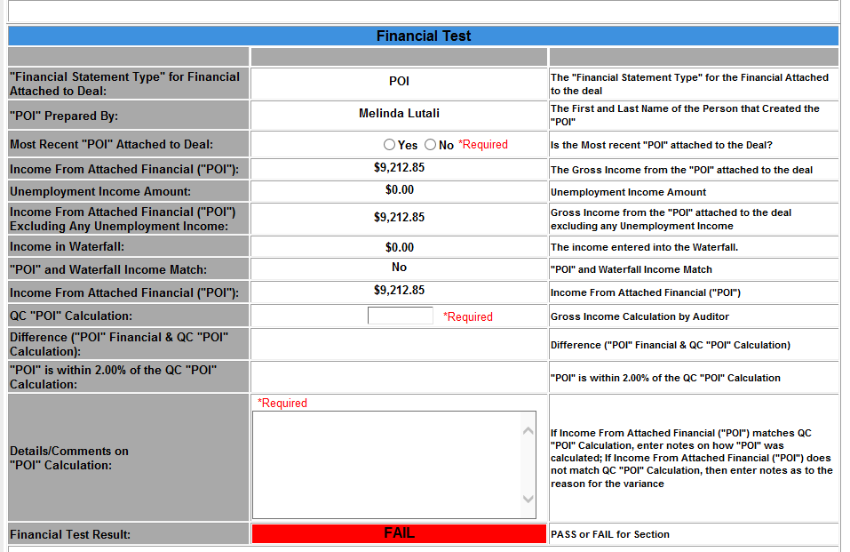  
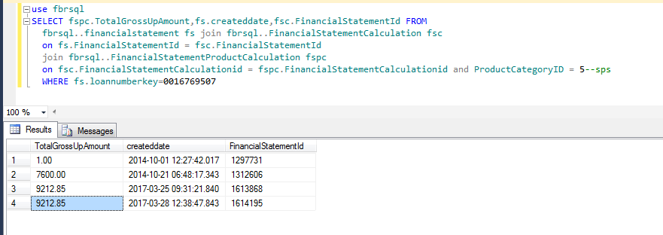  
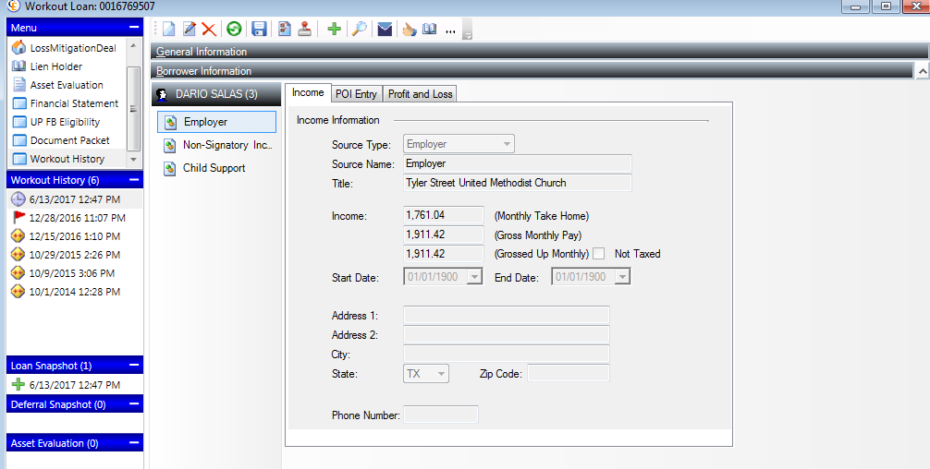  
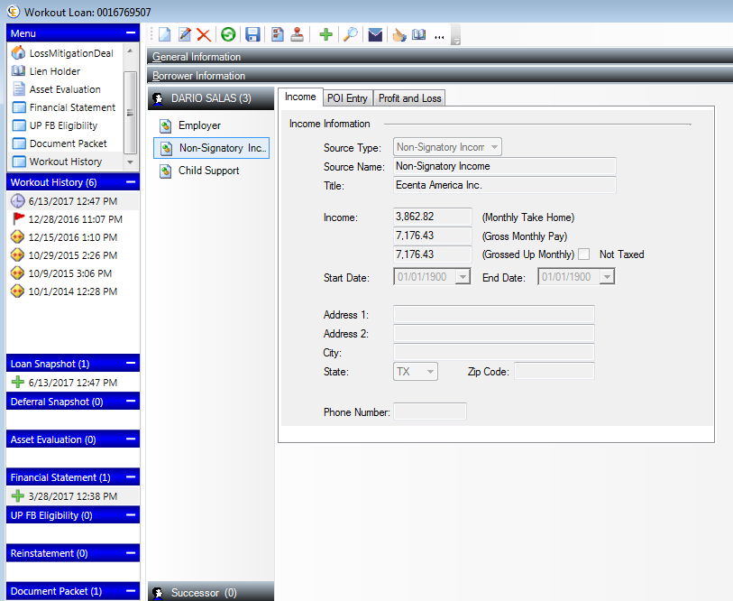  
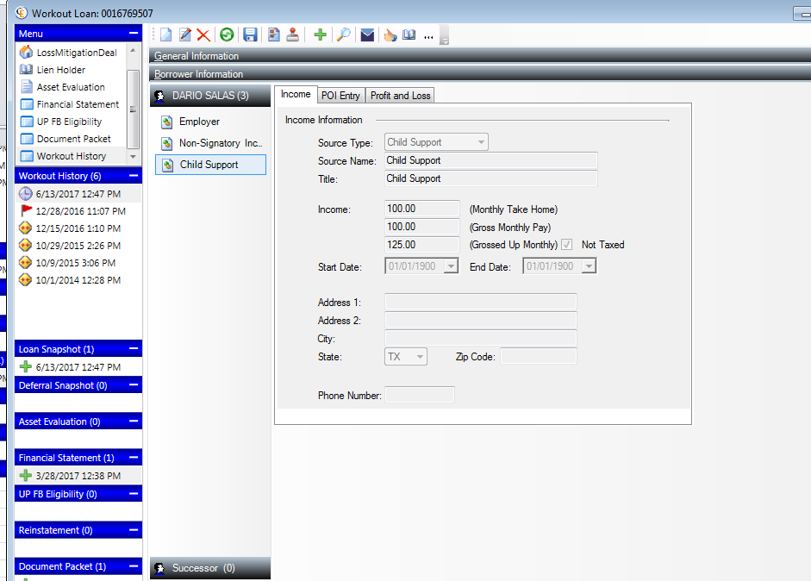

**Updated logic for HOA Test and Insurance Test Section**

HOA should not be displayed in this section as it is covered under the HOA section. The insurance test should compare the monthly amount of insurance listed on the waterfall and the monthly insurance amount from the escrow analysis.

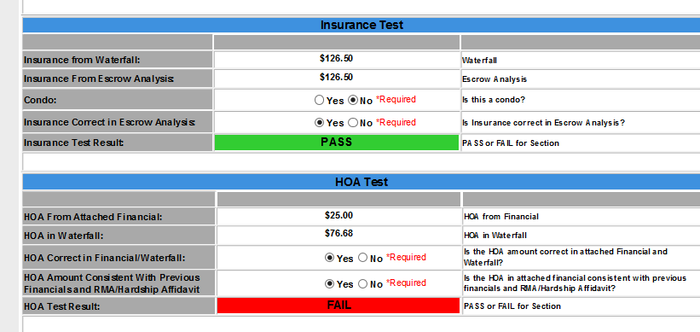

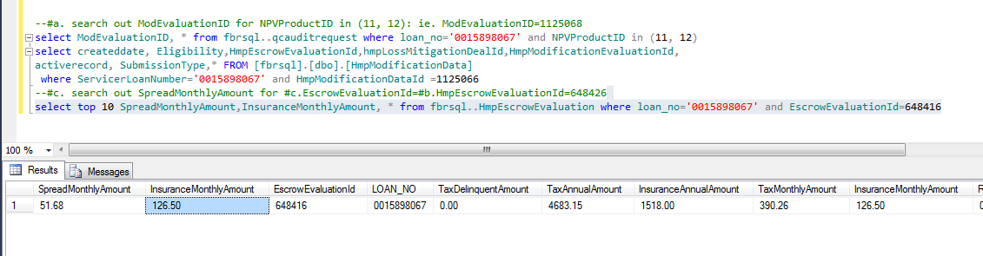

### Added New Denial Reason as ‘HAMP-Not a Natural Person’ to the “HAMP Denials”

Added new denial reason as ‘HAMP-Not a Natural Person’ to the Product “HAMP Denials” only.  
The existing Audit Form (Manual Review) will display to audit When choose the close reason as ‘HAMP-Not a Natural Person’.

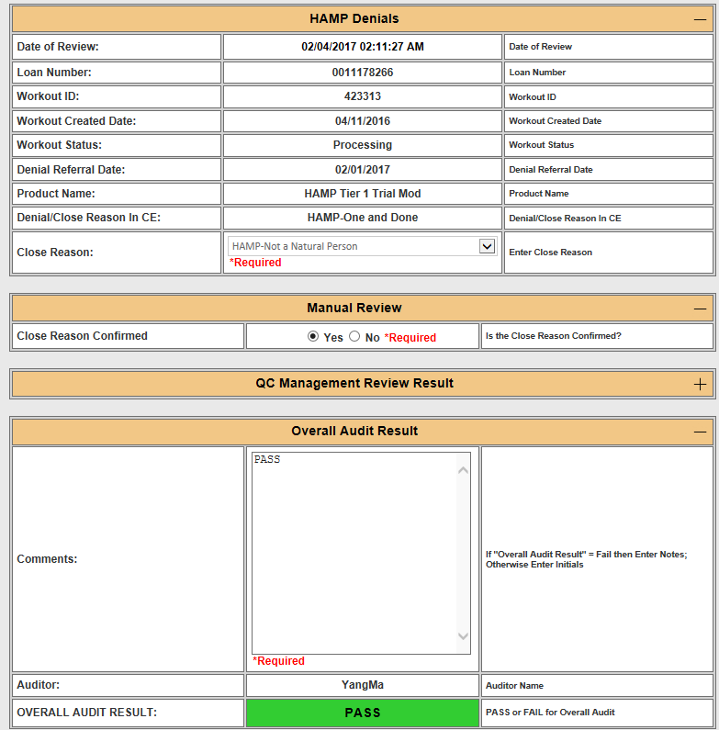

### The denial reason of “Excessive Forbearance” needs to go to Assumption Negative NPV Queue.

Earlier for the Assumption product, the denial reason of “Excessive Forbearance” is going into the Assumption Denials Queue instead of the Assumption Negative NPV Queue through CE. This is incorrect. After updated the respective population SP , it’s going to Assumption Negative NPV Queue correctly.

### Calculation logic updated for all NPV products

The following field logic was modified for all NPV Products such as

* BAC Negative/Positive NPV
* CHAMP Negative/Positive NPV
* HAMP Negative/Positive NPV
* SPS Negative/Positive NPV
* Assumption Negative/Positive NPV

|  |  |
| --- | --- |
| **Fields** | **Modified Logic** |
| CBR Date | Manual entry (CBR date must be within 90 days of NPV submission date, or fail audit) |
| Aging of CBR | Auto calculation (CBR date- NPV submission Date ) |
| Date of BPO/Value Used | Manual entry (BPO date must be within 90 days of NPV submission date, or fail audit) |
| Aging of Value | Auto calculation (Date of BPO/Value Used - NPV Submission Date) |

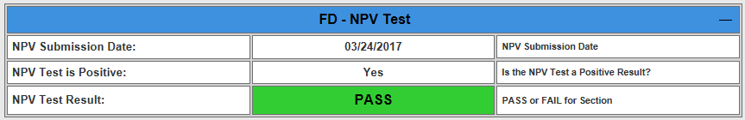

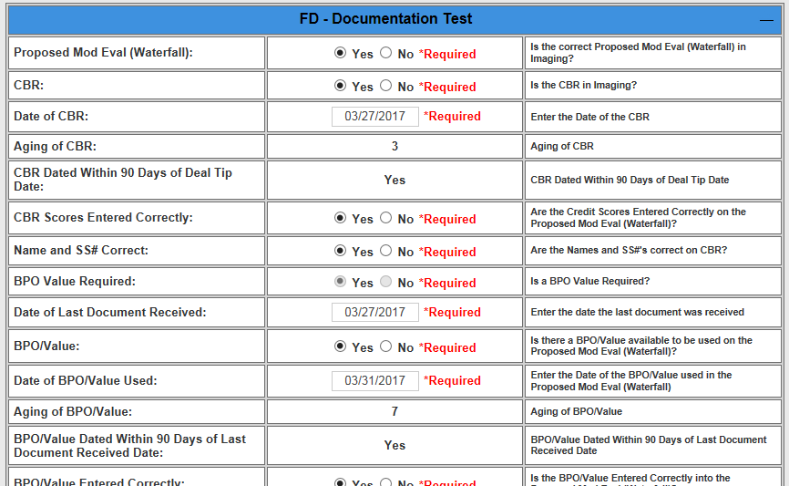

### Admin users can able to edit the NPV values for HAMP Positive/Negative NPV

Admin users can able to edit the NPV values for products (HAMP Positive/Negative NPV) in Old Tool only.

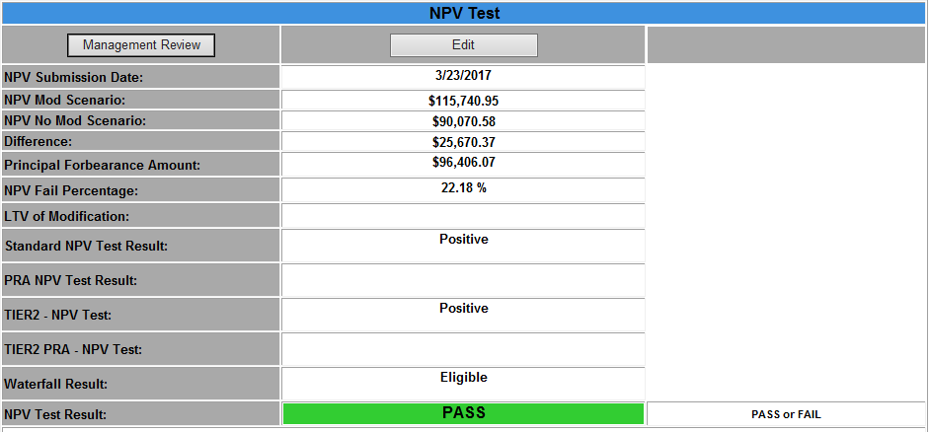

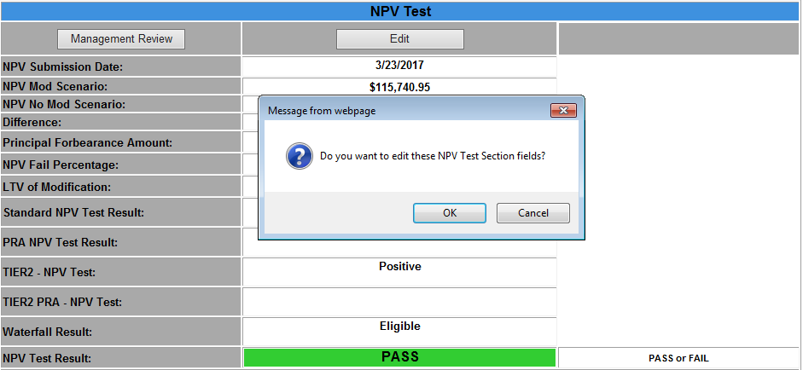

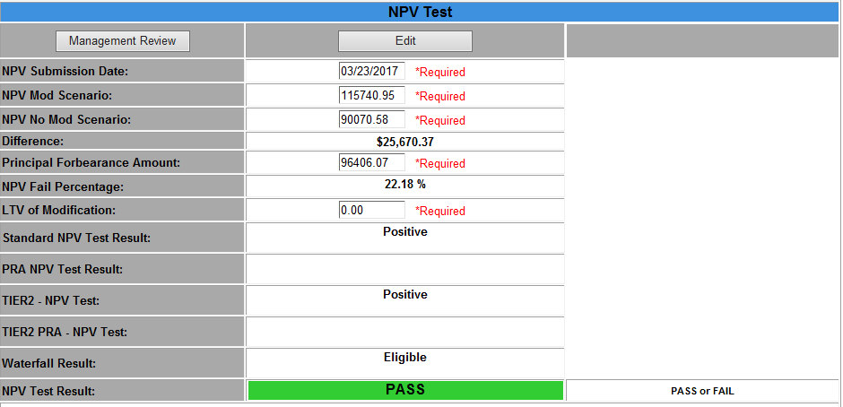

### Added New Close Reason as ‘Investor Denied’ to the “Deferral Denials”

Added new close reason as ‘Investor Denied’ to the Product “Deferral Denials” only.  
The existing Audit Form (Investor Denied) will display to audit When choose the close reason as ‘Investor Denied’  
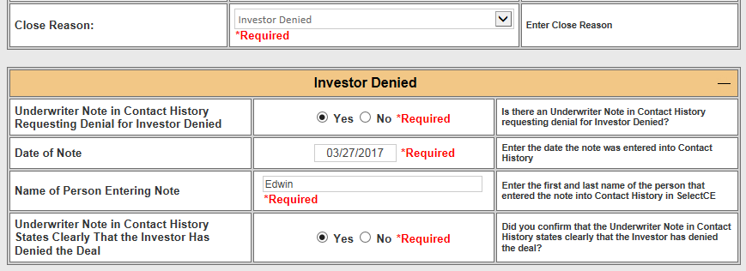

### User can enter comments/notes as “&#” along with numerals in any textboxes

As per earlier system, User can’t able to allow enter any comments/notes as “&#” along with numerals in any textboxes under any AuditTypes.Because System throws the error as “System Error when potentially dangerous Request.Form value was detected”.After that this issue was fixed in both Old & New Tool. PFB screenshot  
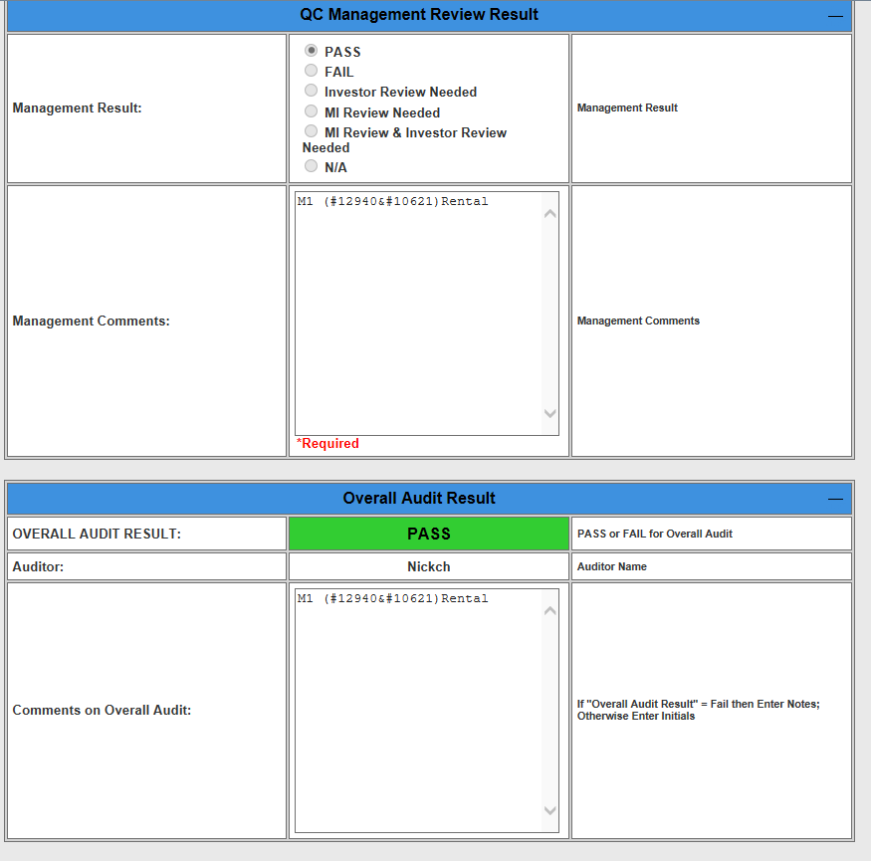

### Added New Denial Reason as ‘Land Only’ to Denial products

Added new denial reason as ‘Land Only’ to the following Denial Products.  
The existing Audit Form (Manual Review) will display to audit When choose the close reason as ‘Land only’ under below Audit Types.

|  |  |  |
| --- | --- | --- |
| **Product Name** | **Audit Type** | **Source** |
| HAMP Unemployment | HAUP Denials | CFPB |
| SPS unemployment | SPS UP Denials | CFPB |
| HAMP Tier 1 Trial Mod | HAMP Denials | CFPB |
| HAMP Tier 2 Trial Mod | HAMP Denials | CFPB |
| BAC Trial Mod | BAC Denials | CFPB |
| JPM Trial Mod | CHAMP Denials | CFPB |
| SPS Trial Mod | SPS Denied | CFPB |
| SPS ALT Trial Mod | SPS Denied | CFPB |
| Deferral | Deferral Denials | CFPB |

### Collateral Audits Request

The following products & Deals are applicable to Collateral Audits request.

|  |  |  |
| --- | --- | --- |
| **Audit Type** | **Product Name  (CFPB)** | **LossMitigationDealSubType (Non- CFPB)** |
| Short Pay Denials | SPS Short Pay BAC Short Pay | Short Payoff Full Document Short Pay |
| Short Sale Denials | SPS Short Sale Review - Listing Period SPS Short Sale Review – No Listing Period BAC Short Sale Review - Listing Period BAC Short Sale Review – No Listing Period JPM Short Sale Review - Listing Period JPM Short Sale Review – No Listing Period | Short Sale Full Document Short Sale |
| DIL Denials | SPS Deed in Lieu BAC Deed in Lieu JPM Deed in Lieu | Full Document DIL Deed In Lieu Conventional Deed In Lieu Conventional PMI |
| HAFA Denials | HAFA Short Sale Review - Listing Period HAFA Short Sale Review – No Listing Period HAFA Deed in Lieu | Short Sale Offer |

### Short Sale Review workout needs to populate into GSE Denials/Approvals Queue

The Govt Ins. Loans has an open Short Sale Review Workout (Listing Period or No Listing Period) with a supporting Offer which needs to populate into the following Queues..

|  |  |  |
| --- | --- | --- |
| **Audit Type** | **Loan_Type** | **WorkOut Option** |
| GSE Denials/Approvals | FNMA FHLMC | GSE Short Sale Review - Listing Period |
| GSE Short Sale Review - No Listing Period |
| VA | VA Short Sale Review - Listing Period |
| VA Short Sale Review - No Listing Period |
| FHA | FHA Short Sale Review - Listing Period |
| FHA Short Sale Review - No Listing Period |
| USDA | USDA Short Sale Review - Listing Period |
| USDA Short Sale Review -No Listing Period |

### Added New Product Audit Queue as “GSE Assumption Denials/Approvals”

Added new Product Audit Queue as “GSE Assumption Denials” and “GSE Assumption Approvals”.  
The below table contains the Close reason with audit form details for the respective Product.  
Note: Loan Types (FNMA, FHLMC, FHA, VA, USDA) routing into the GSE Assumption Denials/Approvals.

|  |  |  |
| --- | --- | --- |
| **Product Audit Queue** | **Close Reason** | **Audit Form** |
| Assumption Denials (Existing) | Loan is Current | Manual Review form |
| GSE Assumption Denials (New) | Access Issues for property valuation | Manual Review form |
| Charge off | Manual Review form |
| Customer Request | Manual Review form |
| Open Error | Manual Review form |
| Paid in Full | Manual Review form |
| Reinstated | Manual Review form |
| Servicing Transfer | Manual Review form |
| Transfer of Ownership | Manual Review form |
| Assets sufficient to reinstate account | Manual Review form |
| Customer No Longer Employed | Manual Review form |
| DTI after Mod > 43% | Manual Review form |
| DTI Outside of Acceptable Range | Manual Review form |
| Excessive Forbearance | Manual Review form |
| Failed NPV | Manual Review form |
| FC Sale < 7 Days | Manual Review form |
| Investor Denied | Manual Review form |
| Loan Is Not Modifiable | Manual Review form |
| LTV < 100% | Manual Review form |
| Mortgage Insurer Denied | Manual Review form |
| New Plan Required | Manual Review form |
| Property is Vacant / Condemned | Manual Review form |
| Required Documents not Received | Manual Review form |
| State Restriction | Manual Review form |
| Financials Do Not Support | Manual Review form |
| Modification not feasible | Manual Review form |
| Ineligible Rental Property | Manual Review form |
| Loan is Not Assumable | Manual Review form |
| Unemployment Income | Manual Review form |
| Existing Obligor | Manual Review form |
| Insufficient Change in Circumstance | Manual Review form |
| Pre-Mod DTI | Manual Review form |
| Not Imminent Default | Manual Review form |
| Manual Review | Manual Review form |
| Bankruptcy Court Declined | Manual Review form |
| Discharged BK Not Reaffirmed | Manual Review form |
| Legal Documents Specify Another Resolution | Manual Review form |
| Loan is Current | Manual Review form |
| Property Not Primary Residence | Manual Review form |
| PSA Restrictions | Manual Review form |
| GSE Assumption Approvals  (New) | NA | Manual Review form |

### Included the QC approved/denied workitem for all CFPB AuditTypes

Included the QC approved/denied workitem in the following population stored procedures which belongs to all CFPB AuditTypes.

|  |  |  |
| --- | --- | --- |
| **No.** | **AuditTypes (CFPB only)** | **CFPB Population SP** |
| 1 | Assumption Denials | QC.GetAssumptionDenialsAudit_xp |
| 2 | Assumption Negative NPV | QC.GetAssumptionNPVRelatedAudits_xp |
| 3 | Assumption Positive NPV |
| 4 | BAC Negative NPV | QC.GetNPVRelatedAuditsForNewTool_xp |
| 5 | BAC Positive NPV |
| 6 | CHAMP Negative NPV |
| 7 | CHAMP Positive NPV |
| 8 | SPS Negative NPV |
| 9 | SPS Positive NPV |
| 10 | BAC Denials | QC.GetBacChampDenialsFROMQCAuditRequest_sp |
| 11 | CHAMP Denials | QC.GetBacChampDenialsFROMQCAuditRequest_sp |
| 12 | Deferral Approvals | QC.GetDeferralApprovalsCFPBAudits_sp |
| 13 | Deferral Denials | QC.GetDeferralDenialsCFPBAudits_sp |
| 14 | DIL Denials | QC.GetDILDenialsCFPBAudits_sp |
| 15 | GSE Approvals | QC.GetGSEApprovalsCFPBAudits_sp |
| 16 | GSE Denials | QC.GetGSEDenialsCFPBAudits_sp |
| 17 | HAFA Denials | QC.GetHAFADenialsCFPBAudits_sp |
| 18 | HAMP Denials | QC.GetHAMPDenialsCFPBAudits_sp |
| 19 | HAMP Negative NPV | QC.GetHampNegativeNPVAuditMain_xp |
| 20 | HAMP Positive NPV | QC.getHAMPPositiveNPVAuditMain_xp |
| 21 | HAUP Approvals | QC.GetUPApprovalsAudit_xp |
| 22 | SPS UP Approvals |
| 23 | HAUP Denials | QC.GetUPDenialsAudit_xp |
| 24 | SPS UP Denials |
| 25 | NMS Denials | QC.GetDOJDenialsAudit |
| 26 | NMS Negative NPV | QC.getDOJ_DeniedAuditMain_xp |
| 27 | NMS Positive NPV | QC.getDOJ_ApprovedAuditMain_xp |
| 28 | Short Pay Denials | QC.GetShortPayDenialsCFPBAudits_sp |
| 29 | Short Sale Denials | QC.GetShortSaleDenialsCFPBAudits_sp |
| 30 | SPS Denied | dbo.GetSpsDeniedAuditMain |
| 31 | GSE Assumption Approvals | QC.GetGSEAssumptionApprovalsCFPBAudits_sp |
| 32 | GSE Assumption Denials | QC.GetGSEAssumptionDenialsCFPBAudits_sp |

## Admin Tab Functionality

This tab contains three sections.

### Cancel Workout

This section is for CFPB data only.

All the active products under the given workout ID can be canceled.

#### 

### Unlock Workout

This section will reset the audits/workout status from **Processing** to **Queued**.

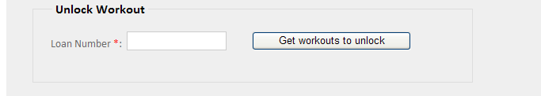

Input a loan number, and click “Get workouts to unlock”, then you will get all the **processing** workouts associated with this loan.

In this workout list, select one workout, and click “Unlock” button to unlock workout, then it will update both workout and audit status from processing to Queued.

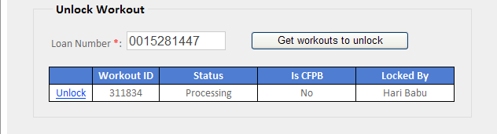

### Populate Data

This section allows user to:

Call stored procedure to populate **CFPB** audits.

And the procedure cannot be called again when it is being called.



### Reassign

This section allows user to reassign a workout from current auditor to another specific user.

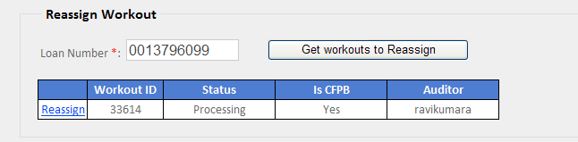

Input a loan number, and click “Get workouts to Reassign”, then you will get two kinds of workouts associated with this loan, one kind is the workout is in processing status, another is in this workout, some audits get failure during submission. Then select a workout and click “Reassign”, and below dialog will show, user can select a user to reassign to, all the QC users will be list in the drop down, click “Yes” then the Reassign process will complete.

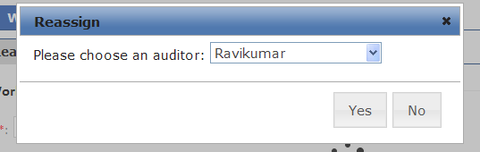

## HAMP/HAFA/HAUP Tab Functionality

This page displays five audit types, every audit type has its own page/tab and it will display the loans for that type.

* HAFA Completed
* HAMP Completed
* HAFA Denied
* HAUP Denied
* HAUP Completed

Each page contains search section, events table, and Audit tab. AS HAMP Denials , HAMP Completed ,HAFA Denials , HAFA Completed are migrated to new tools , data will no longer be populated into HAMP Closed, HAMP Completed, HAFA Denied , HAFA Completed in old tool .

### Search

* Initially when the page loads it displays all the audits with the below criteria
  + Audit status =’ Queued’
  + Start Date = Created date for the oldest record
  + End Date = Current date
* **Search Criteria**:
* Deal ID
* Status
* Loan No
* Status
* Start Date
* End Date

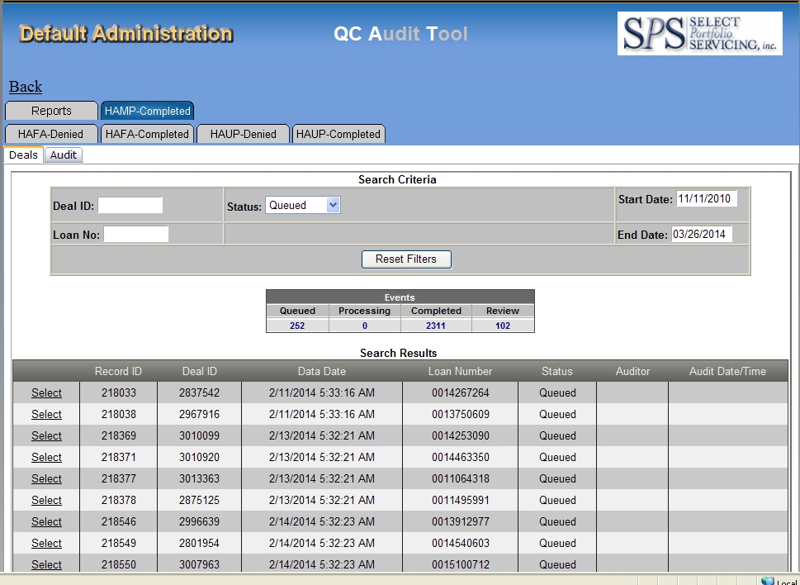

### Events table

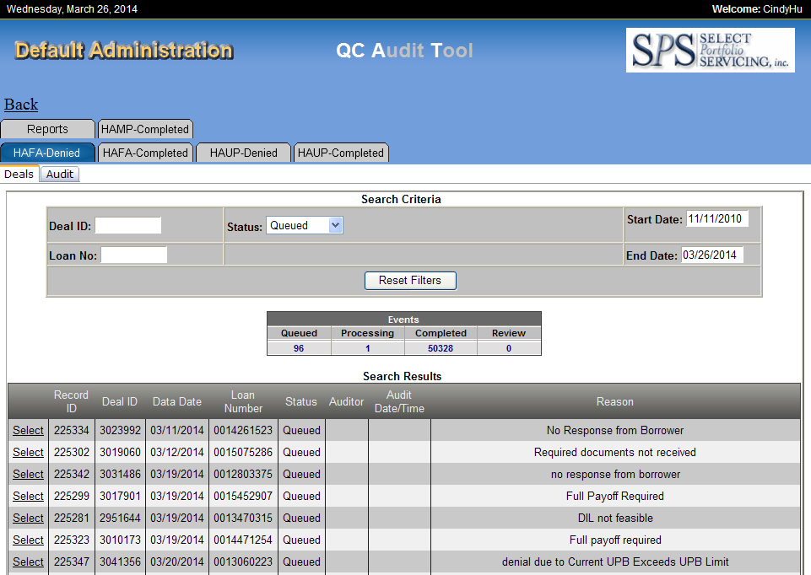

From above picture we know in Events table it displays this audit type of different status’ loan number. There are 96 loans in Queued status, 1 loan in Processing status, 50328 loans in Completed status and 0 in Review.

### Audit screen

Select one of loan number which is in queued status, then you can audit it.

Screen like below:

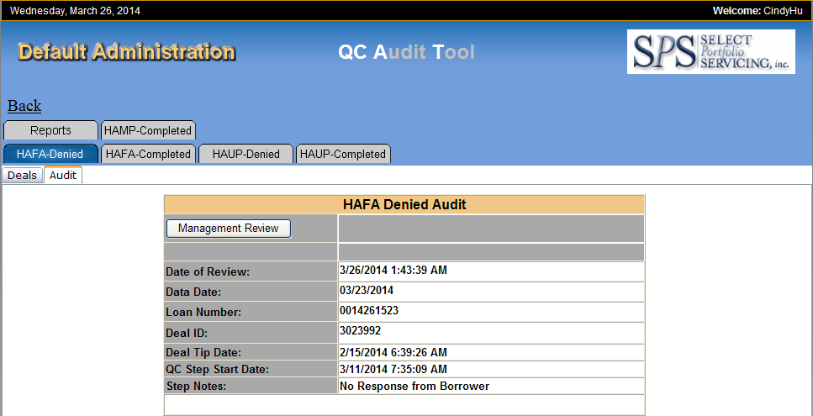

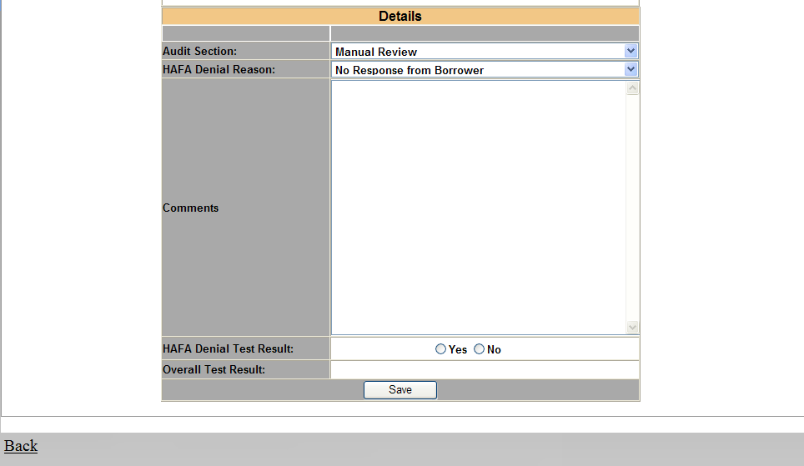

The selected audit may contain multiple sections, but for HAFA Denied Audit, it has one section.

**Management Review:**

By clicking “Management Review” button, it will send an email to specific group (defined in table QC.ConfigInfo, ConfigKey: ReviewDistributionList), and this audit’s status will be changed from “**Processing”** to “**Review”**.

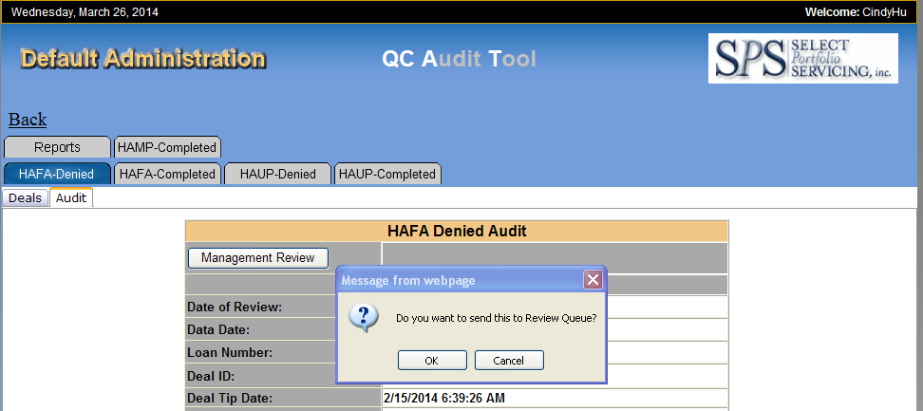

**Details Section:**

There are different fields defined for each section.

User must enter all the required fields’ value in each field, then the test result (PASS/FAIL/REVIEW NEEDED) or any other derived column data will be calculated automatically based on the business logic after the field value has been changed.

Screen like below:

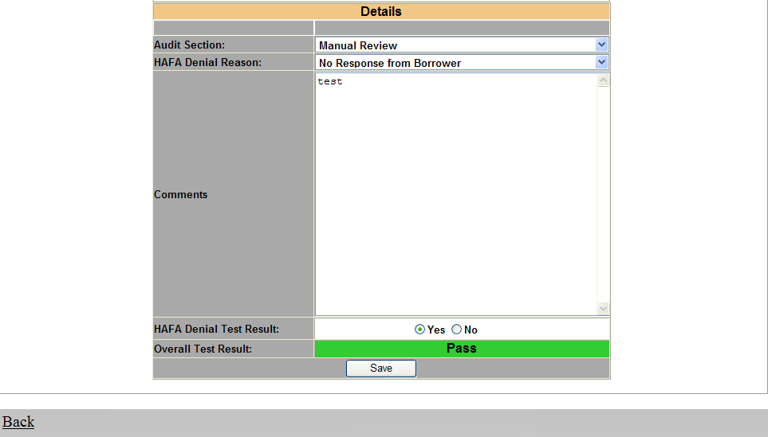

**Save Audit:**

When user clicks the “Save” button, after validation successfully, the PDF file will be generated in configured path (defined in table QC.ConfigInfo, ConfigKey: SaveToFilepath), and the contact history will be update and audit status will be changed from “**Processing”** to “**Complete”**. For non-CFPB data, it will pop up a warning message like above picture said “Please also update checklist step for this loan.”

## Functions

### PDF File Generation

After an Audit is completed successfully it will generated a PDF file. The detail process as below:

* + All the audit field value will be formatted as XML.
  + Format XML to XSL-FO using predefined file.
  + Calling ConverterService service to convert data from XSL-FO format to PDF format.

### Common Data Copy

This is for CFPB audits only.

As one workout may have several products. Each product has its own audit form.

When auditor fills the one audit form, the common data should be copied to the other audit forms for that Workout, which saves user effort.

* When submitting the audit, common field data will be saved in table QC.SharableValue.
* When loading the audit form and the audit status is processing, the common data will be loaded from table QC.SharableValue.

This functionality exists for below products:

* BAC Trial Mod
* HAMP Tier 1 Trial Mod
* HAMP Tier 2 Trial Mod
* JPM Trial Mod
* NMS Trial Mod
* SPS Trial Mod

### Actual/Alternate Option Form

This is for CFPB audits only.

As we have multiple products in one workout, order by product EligibilityPriority, all products below the 1st Positive NPV Result will use alternate option form, others use actual form.

Product “HAMP Unemployment”, “SPS Unemployment” always shows actual form.

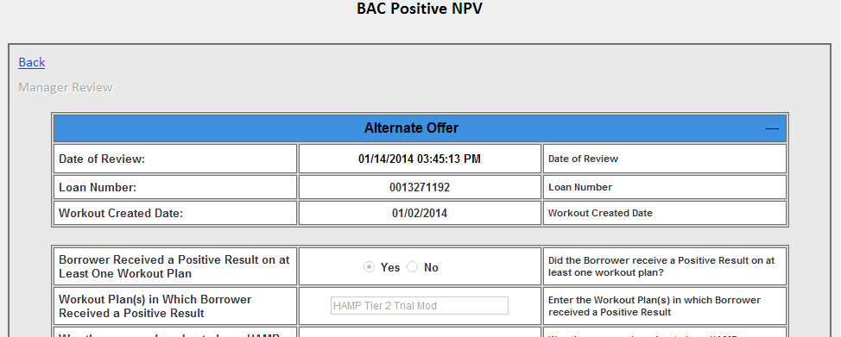

Manual Review is added to all the Alternate Option form.  
The changes are applicable to the below audit types queues in QC Audit Tool.

1. BAC Negative NPV  
2. BAC Positive NPV  
3. BAC Denials  
4. CHAMP Negative NPV  
5. CHAMP Positive NPV  
6. CHAMP Denials  
7. SPS Positive NPV  
8. SPS Negative NPV  
9. HAMP Denials  
10. Deferral Denials  
11. Deferral Approvals  
12. SPS Denied  
13. Champ Positive NPV  
14. Champ Negative NPV

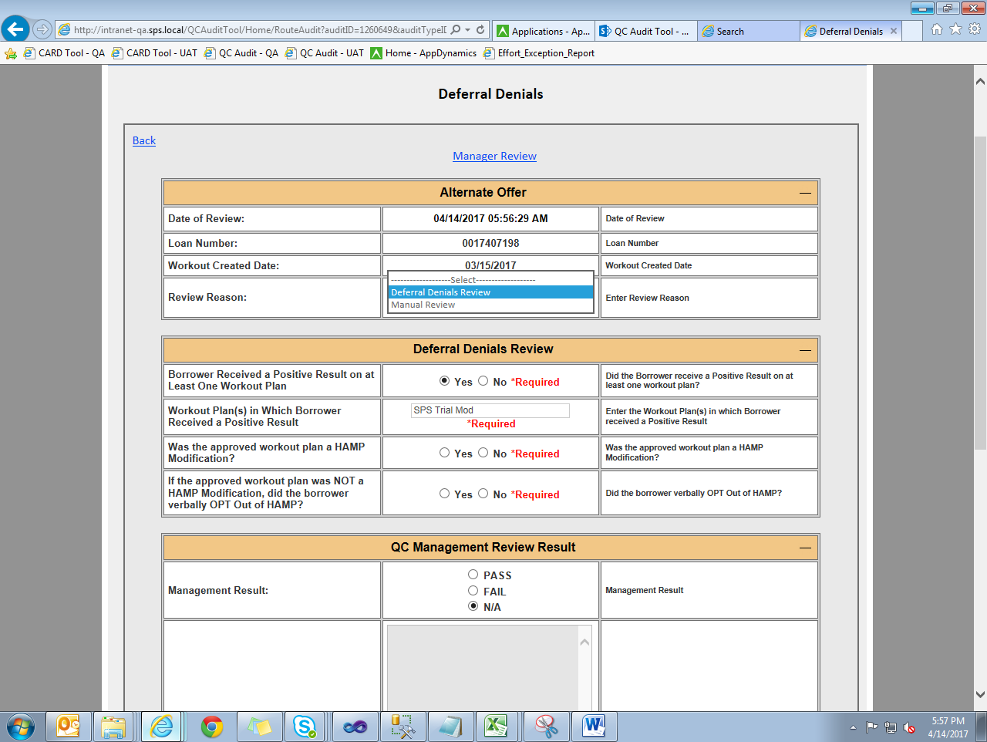

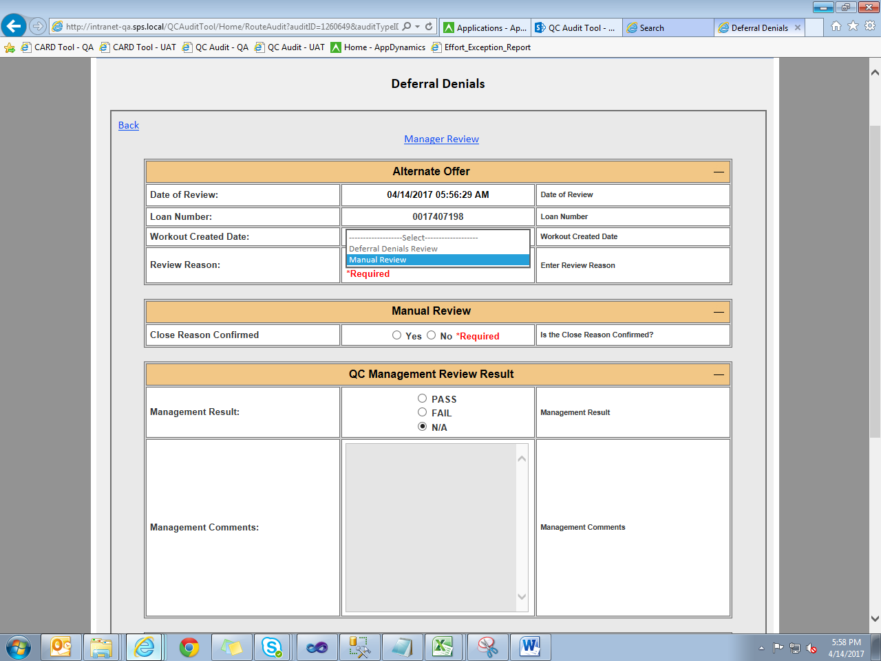

### POI Calculation

POI calculation button should be only enabled the first time for all users. If POI has a value then the button should be always disabled on audit form. Admin can change this value under admin tab for each workout. When the POI value is changed in admin tab the audit loan in workout may also be changed according on current status.

